**KVON TECH**

**OUESTION PAPER**

Topics: - Total Marks: - **20**

* HTML
* CSS
* Bootstrap

1. Create the following UI using HTML and CSS only and the sidebar having social media icons should not be scrollable.

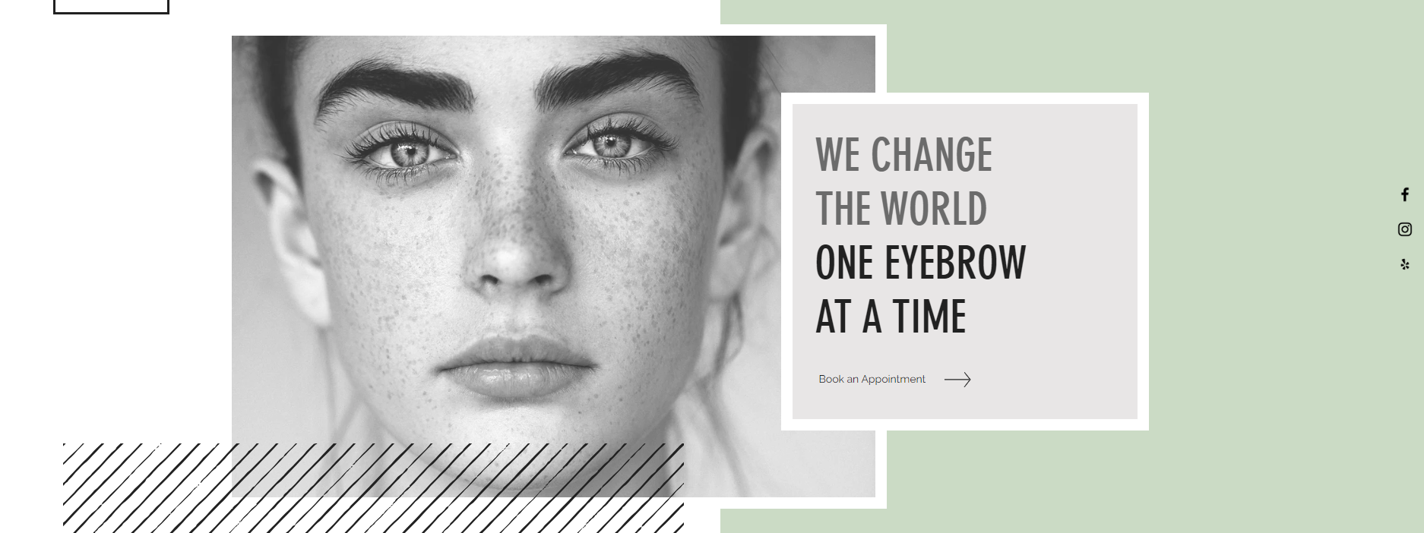

1. Explain the difference between the following CSS properties with examples:

* display: block
* display: inline-block
* display: none

Write the CSS code to center a div both vertically and horizontally within a webpage using Flexbox.

1. Implement Bootstrap Carousel with 3 slides and on large screen size all the 3 images display at once and on smaller screen size only single image should be visible.
2. Implement the following Card using Bootstrap and apply a transition over the hover.

**After HOVER**

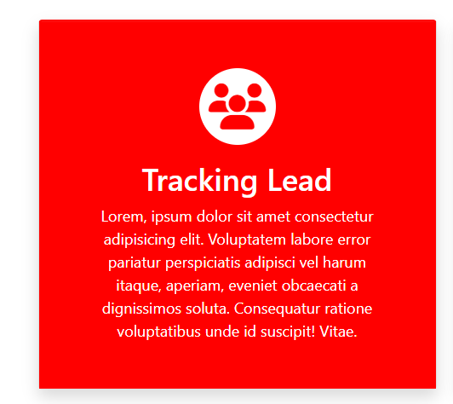

**Before HOVER**

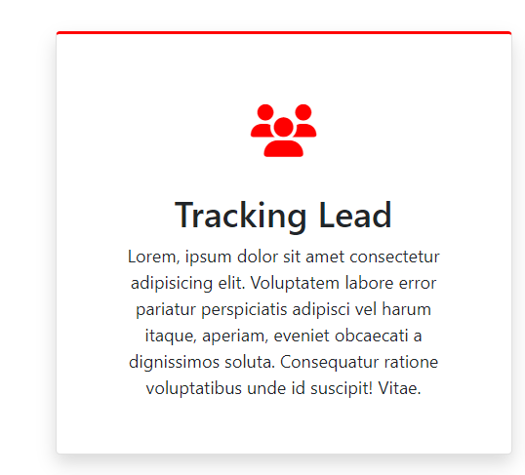

1. Implement Tabs in bootstrap having values Home, About Us and Contact Us to display their respective content when I click on any particular Tab.
2. Design the following form using every input attribute [country=dropdown]. Add checkbox for Gender and a Button[value=Submit]

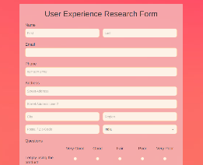

1. Difference between

* class and id attribute
* Relative and Absolute position
* em, rem and px
* padding and margin